BTSHOL07: Integration with POP3 and SharePoint and Handling Failed Messages
90

This lab will demonstrate how to configure the POP3 and SharePoint adapters for BizTalk Server 2010. Additionally it will demonstrate how to build and configure an orchestration that subscribes to failed messages.
Overview
After completing this lab, you will be able to:
Objectives
- Create and configure a receive location that uses the POP3 adapter.
- Configure send ports and receive locations that use the Windows SharePoint Services adapter.
- Create an orchestration that subscribes to failed messages and adds error information to the original message.

First, you will test an existing application to learn how it works. Then you will configure a Receive Location to use a POP3 adapter to receive expense reports sent as email attachments. Next, you will create a Send Port that writes new expense reports to a SharePoint site for manual approval or denial. Then, you will configure a second Send Port that will write the processed expense reports to another SharePoint library. Finally, you will configure a Receive Location to process the approved or denied expense reports.
Scenario
Once you have tested the configuration of these new adapters, you will build an orchestration that will subscribe to any failed messages that are generated when an invalid expense report is submitted. The orchestration will add error details to the original message and write the message to a SharePoint site where it can be reviewed and fixed.
Estimated time to complete this lab: 75 minutes

User Name: Administrator
Password: pass@word1

Exercise 1
Examine and Test the Approval Process Orchestration
This orchestration is used to send pending expense reports to the accounting department where the expenses are either approved or denied. The expense report is transformed into an acknowledgement, with additional information for the employee and sent to the employee and the accounting department to be archived. In this exercise, you will test the orchestration and see how it works using only the file adapter.

Tasks | Detailed steps
- Open the BizTalk Server 2010 Solution. | - From C:\Labs\Lab 7\Start\ directory, open SharepointLab.sln.
- Examine the ApprovalProcess Orchestration. | - In Solution Explorer, double-click the ApprovalProcess.odx orchestration to open it  - Examine the orchestration.  - Right-click on the ErrorHandling project in the Solution Explorer and select Deploy.  While examining the orchestration, notice the message (an expense report) is received and then sent for manual approval. The expense report is evaluated for a Status code of Denied. The message is then transformed into the ProcessedExpenses message type, and a Message Assignment shape is used to create explanation of why the expense report was denied or to confirm the approval. The new message is then sent to the accounting department and the employee.
- Start the Application | - On the Start menu, point to All Programs, then point to Microsoft BizTalk Server 2010, and then click BizTalk Server Administration.  - In BizTalk Administration Console, expand BizTalk Server 2010 Administration > BizTalk Group > Applications > Lab7.  - Right-click on Lab7 and select Import->Bindings. Browse to C:\Labs\Lab 7\Start\Setup\Lab7.xml and click Open.  This will create all ports and orchestration bindings.  - Right-click on Lab7 and select Start.  - Click the Start button.
- Submit a test message to ensure that the Orchestration is processing correctly. | - In Windows Explorer, navigate to C:\Labs\Work\Lab 7\Messages.  - Copy the Over100.xml message to the IN folder.  - Navigate to the C:\Labs\Work\Lab 7\Messages\Approval-Denial OUT folder.  - Double-click the {GUID}.xml file to open it in InfoPath.  - Change the Status to Declined.  - Save and close the form.  - In Windows Explorer, move the {GUID}.xml file from the Approval-Denial OUT folder to the Approval-Denial IN folder.  - Navigate to the OUT folder and open the message (this message will open in Internet Explorer and not InfoPath).  - Notice that the Explanation note has been added with a comment that the expenses were denied.  - Close the message and delete it from the OUT folder.  - In Windows Explorer, navigate to C:\Labs\Work\Lab 7\Messages.  - Copy the Under100.xml message to the IN folder.  - Navigate to the C:\Labs\Work\Lab 7\Messages\Approval-Denial OUT folder.  - Double-click the {GUID}.xml file to open it in InfoPath.  - Change the Status to Approved.  - Save and close the form.  - In Windows Explorer, move the {GUID}.xml file from the Approval-Denial OUT folder to the Approval-Denial IN folder.  - Navigate to the OUT folder and open the message.  - Notice that the Explanation note has been added with a comment that the expenses were approved.  - Close the message and delete it from the OUT folder.  Messages in this folder represent email messages that will be sent to the employee.  - Navigate to the C:\Labs\Work\Lab 7\Messages\OUT\Accounting folder and delete the two messages there.  This folder represents the SharePoint form library where the processed messages sent to the accounting department will be saved.

Exercise 2
Configure and Test the POP3 Adapter
The POP3 adapter is used to receive messages into BizTalk Server 2010 via email. The messages can be sent as attachments or be contained in the email message body. In this exercise, you will create a new receive location which uses the POP3 adapter. Once you have configured the receive location, you will send an XML document as an email attachment and complete the business process.

Tasks | Detailed steps
- Use the BizTalk Administration console to create and configure a receive location.  This new receive location will be added to the existing receive port, allowing message to be received into the same logical port with a different adapter and pipeline.  The POP3 adapter is used to receive messages via email. Either message body or attachments can be processed by BizTalk. The Message Part Index property specifies whether the body or attachment will be processed. Expense reports will be sent as email attachments. | - On the Start menu, point to All Programs, then point to Microsoft BizTalk Server 2010, and then click BizTalk Server Administration.  - In BizTalk Administration Console, expand BizTalk Server 2010 Administration > BizTalk Group > Applications > Lab7.  - Right-click Receive Locations, point to New, and then click One-way Receive Location.  - In the Select a Receive Port dialog box, click RcvExpenses, and then click OK.  - In the Receive Location Properties window, change the Name to RcvExpensesPOP3, then select POP3 from then Type list, and then click Configure.  - In the POP3 Transport Properties dialog box, set the configuration as shown in the table below:  - In the POP3 Transport Properties dialog box, click OK.  - Choose XMLValidateReceivePipe from the Receive pipeline list.  - In the Receive Location Properties window, click OK.
  Property | Value
  Body Part Index | 2
  Mail Server | localhost
  Authentication Scheme | Basic
  Password (you must use the drop down in this property box to fill out the password) | pass@word1
  User Name | Expenses@bts2010.com
  Polling Interval Unit | Seconds
- Enable the receive location. | - In the left pane of the BizTalk Administration Console, expand Lab7 and click Receive Locations.  - In the right pane, right-click RcvExpensesPOP3, and then click Enable.
- Enable the mail server | - From the Start menu choose hMailServer Administrator. This is needed to enable the mail service.
- Create and send an email message with an expense report attached. | - From the Start menu choose All Programs | Windows Live Mail.  - In Windows Live Mail, click the Create Mail button.  - In the New Message window, type Expenses@bts2010.com in the To field, and then type Expense Report Submittal in the Subject line.  - On the Insert menu, click File Attachment.  - In the Insert Attachment dialog box, navigate to C:\Labs\Work\Lab 7\Messages, then select Over100.xml, and then click Attach.  - In the Expense Report Submittal window, click Send.
- Complete the business process.  If you don’t complete the business process, this orchestration will be dehydrated and may cause problems when redeploying. | - In Windows Explorer, navigate to C:\Labs\Work\Lab 7\Messages\Approval-Denial OUT.  Notice that the message was successfully received through the POP3 adapter.  - Move the {GUID}.xml message to the Approval-Denial IN folder.  This completes the manual approval process for the expense report.  - Navigate to the OUT folder and delete the message that appears there, and then navigate to the Accounting folder and delete the message there.  This step is to clean up the message folders for the processed files.
- Stop the BizTalk application.  Since the next exercise requires the modification of send and receive ports, the orchestration must be stopped. | - In the left pane of the BizTalk Administration Console, right-click Lab7, and then click Stop.  - In the Stop ‘Lab7’ Application dialog box, click Full Stop – Terminate instances, and then click Stop.

Exercise 3
Modify Two Send Ports to Use the SharePoint Adapter.
The Windows SharePoint Services adapter is used to send or receive messages to/from a SharePoint document library. This integration provides a great way to manage and store messages. In this exercise, you will modify two of the send ports to use the SharePoint adapter.

Tasks | Detailed steps
- Change the name and transport type for the SndForApprovalFILE send port. | - In the left pane of the BizTalk Administration Console, under Lab7, click Send Ports.  - In the right pane, double-click SndForApprovalFILE.  - In the Send Port Properties window, change the Name to SndForApprovalWSS, and then from the Type list, click Windows SharePoint Services.
- Configure the SharePoint adapter.  The Destination Folder URL property is known as the form/document library on the SharePoint site.  The adapter relies on a web services installed on the SharePoint server. This was handled for you in the setup process.  The custom send pipeline ensures that the document has the correct processing instruction so the InfoPath form is loaded to view the file. | - Click Configure.  - In the Windows SharePoint Services Transport Properties dialog box, configure the following properties:  - Click OK.  - In the Send Port Properties dialog box, change the Send pipeline to PIXMLSendPipeline, and then click OK.
  Property | Value
  Adapter Web Service Port | 80
  Destination Folder URL | Expense Reports
  SharePoint Site URL | http://localhost
- Change the name and transport type for the SndAccountingAckFILE send port. | - In the left pane of the BizTalk Administration Console, click Send Ports.  - Double-click SndAccountingAckFILE.  - In the Send Port Properties window, change the Name to SndAccountingAckWSS, and then select Windows SharePoint Services from the Type list.
- Configure the SharePoint adapter and pipeline.  In addition to configuring the adapter to send the XML to the SharePoint library, the XmlAssembler component needs to add the correct processing instructions to the XML file to make sure it references the correct InfoPath form template. | - Click Configure.  - In the Windows SharePoint Services Transport Properties dialog box, configure the following properties:  - Click OK.  - In the Send Port Properties window, ensure that the Send pipeline is set to PIXMLSendPipeline.  - Click the ellipses next to the Send pipeline drop down to configure the send pipeline settings.  - Open the AccountingPI.txt file from the start directory at C:\Labs\Lab 7\Start and copy the contents.  - Paste the processing instructions into the XmlAsmProcessingInstructions property in the pipeline configuration dialog.  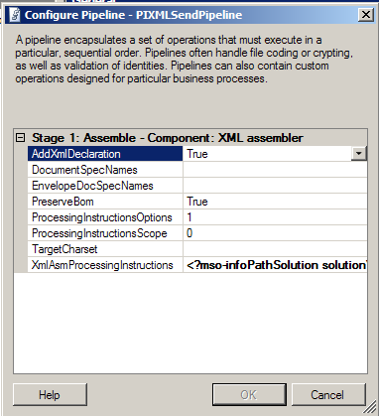  - Click OK twice to complete the send port configuration.
  Property | Value
  Adapter Web Service Port | 80
  Destination Folder URL | Processed Expense Reports
  SharePoint Site URL | http://localhost
Exercise 4
Modify a Receive Location to Use the SharePoint Adapter
90
The Windows SharePoint Services adapter uses SharePoint views to know which documents should be processed from the SharePoint site. The “Processed” view has been preconfigured. This view looks at all documents with Status that does not equal New (the SharePoint Document Library uses a column name of ReportStatus for this value). In this exercise you will edit an existing receive location to use the SharePoint adapter to poll the Processed view of the Expense Reports document library.

Tasks | Detailed steps
- Change the name and transport type of an existing receive location. | - In the left pane of the BizTalk Administration Console, click Receive Locations.  - In the right pane, double-click RcvApproval-DenialFILE.  - In the Receive Location Properties window, change the Name to RcvApproval-DenialWSS.  - Select Windows SharePoint Services from the Type drop-down list.
- Configure the SharePoint adapter properties.  The SharePoint adapter uses views which are specified on the SharePoint site. Any files that are in the view that the SharePoint adapter uses will be processed. | - Click Configure.  - In the Windows SharePoint Services Transport Properties dialog box, configure the following properties:  - Click OK.  - In the Receive Location Properties window, click OK.
  Property | Value
  Adapter Web Service Port | 80
  Polling Interval | 15
  SharePoint Site URL | http://localhost
  Source Document Library URL | Expense Reports
  View Name | Processed

Exercise 5
Test the Application
The application is now ready for testing. The expense report message will be received as an email attachment and then posted to the Expense Reports document library. The expense report is then evaluated and manually approved or denied. Next, the message is picked up by the RcvApproal-DenialWSS receive location by the WSS adapter and processed by BizTalk. Finally, the acknowledgment is posted simultaneously to a different SharePoint document library and a file folder.
In this exercise, you will test the application by sending the email message, changing the status of the expense report on the SharePoint site, and then checking to ensure that the transformed message has been posted back to the SharePoint site.

Tasks | Detailed steps
- Start the BizTalk application. | - In the left pane of the BizTalk Administration Console, right-click Lab7, and then click Start.  - In the Start ‘Lab7’ Application dialog box, click Start.
- Create and send an email message with an expense report attached. | - On the Start menu, point to All Programs, and then click Windows Live Mail (or use the desktop shortcut).  - In Windows Live Mail, click the Create Mail button.  - In the New Message window, type Expenses@bts2010.com in the To field, and then type Expense Report Submittal in the Subject line.  - On the Insert menu, click File Attachment.  - In the Insert Attachment dialog box, navigate to C:\Labs\Work\Lab 7\Messages, then select Over100.xml, and then click Attach.  - In the Expense Report Submittal window, click Send.  - Repeat the previous steps to send another message with the Under100.xml file attached.
- Approve one of the expense reports. | - In Internet Explorer, browse to http://localhost  - In the left pane of the Team Web Site, click Expense Reports library.  - Click the first Msg-{GUID} link.  - In the File Download dialog box, click Open.  The message opens in Microsoft Office InfoPath 2007 If you get a security warning, click through it and open the InfoPath document.  - If the amount of the expense report is less than $100, choose Approved on the Status list. If the amount of the expense report is more than $100, choose Declined on the Status list.  - Save and close the InfoPath form.

- Decline one of the expense reports. | - Click the second Msg-{GUID} link.  - In the File Download dialog box, click Open.  The message opens in Microsoft Office InfoPath 2007.  - If the amount of the expense report is less than $100, choose Approved on the Status list. If the amount of the expense report is more than $100, choose Declined on the Status list.  - Save and close the InfoPath form.  - Wait a few seconds and then in Internet Explorer, click Refresh.  The two messages have disappeared. Since the Status has been changed, they have been picked up for additional processing by BizTalk Server.
- Navigate to the Processed Expense Reports form library to view the processed messages | - In Internet Explorer, in the upper left, click the Documents link at the top of the page.  - Under the Document Libraries section, click the Processed Expense Reports link.  - Open each of the messages to view the expense reports processed by BizTalk.  - Close Internet Explorer.
- Stop the BizTalk application.  Since the next exercise deploying a new version of the assembly, the application and orchestrations need to be stopped. | - In the left pane of the BizTalk Administration Console, right-click Lab7, and then click Stop.  - In the Stop ‘Lab7’ Application dialog box, click Full Stop – Terminate instances, and then click Stop.

Exercise 6
Create an Orchestration to Handle Failed Messages
Now that the expense reports can be submitted via email, and manually approved or denied using the SharePoint site, you need to build a user interface for handling expense reports that contain invalid information. This feature of BizTalk Server 2010 is known as failed message routing. The goal is to create an orchestration that will subscribe to failed messages. The orchestration will add information from the error report that is generated when the message fails, to the message and then send it out of the BizTalk orchestration process for human intervention.
In this exercise, you will create an orchestration that processes failed messages; you will then write two expressions that will add the error report information to the failed message.

Tasks | Detailed steps
- Add a new orchestration to the Error Handling project. | - In the Visual Studio 2010 Solution Explorer, right-click the Error Handling project, point to Add, and then click New Item.  - In the Add New Item dialog box, click Orchestration Files in the left pane, then in the Name box, type ErrorHandler.odx, and then click Add.
- Create the messages used by the orchestration.  The orchestration will use two general XML message types. These messages will act as containers for the error message generated when an invalid message is submitted. | - In Orchestration View, right-click Messages, and then click New Message.  - In the Properties window of the message, change the Identifier to FailedMessage.  - In the Message Type list, expand .NET Classes, and then click System.Xml.XmlDocument.  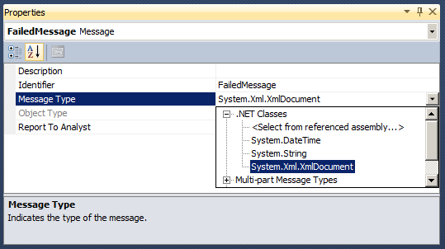  - Repeat the previous steps to create another message with an Identifier of ErrorReportMessage.
- Add the receive shape to the ErrorHandler orchestration.  The orchestration will subscribe directly to the message box. This means that there isn’t a physical port passing messages to the orchestration. The orchestration will be used to process failed messages that are received through the RcvExpenses port. | - In the Orchestration Designer surface, right-click Drop a shape from the toolbox here, point to Insert Shape, and then click Receive.  - Configure the receive shape as shown in the table below.  - In the Properties window of the Failed Message IN receive shape, click the Ellipsis (…) button next to Filter Expression.  - In the first line of the Filter Expression dialog box, set the Property to ErrorReport.ErrorType, set the Operator to ==, and then type "FailedMessage" as the Value (include quotes).  - Click Click here to add a new row!  - On the second line of the filter expression, set the Property to ErrorReport.ReceivePortName, set the Operator to ==, and then type "RcvExpenses" as the Value (include quotes).
  Property | Value
  Activate | True
  Message | FailedMessage
  Name | Failed Message IN

Your Filter Expression should look like this.
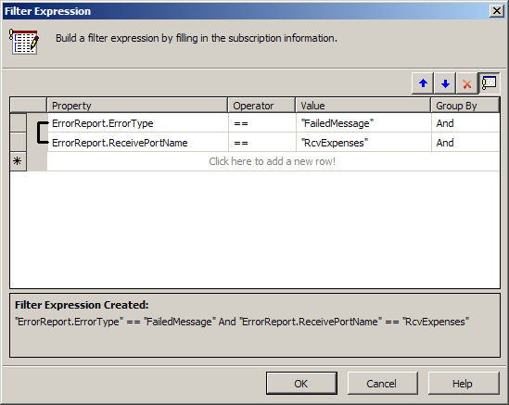
- Click OK
- Set the orchestration to be a long running transaction.  Any orchestration which contains another transaction must be a long running transaction itself. | - Click the Orchestration Start Shape (the green circle at the top of the orchestration).  - In the Properties window, set the Transaction Type to Long Running.
- Add a Scope shape to the orchestration. | - Right-click the down-pointing arrow below the Failed Message IN shape, point to Insert Shape, and then click Scope.  - Configure the Scope with the following properties:
  Property | Value
  Transaction Type | Atomic
  Retry | False
  Name | Construct ErrorReport
- Add two variables to the Construct Error Report scope shape.  These variables will be used in expression shapes to create the error message.  The atomic scope is required because the XmlDcoument class is not serializeable. By scoping the variable to the atomic transaction, you guarantee that the orchestration will not attempt to persist for the duration of the scope. | - In Orchestration View, expand Construct Error Report, then right-click Variables, and then click New Variable.  - Change the Identifier to markup, and then set the Type to String.  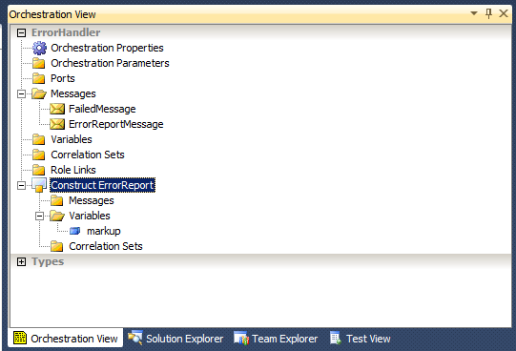  - Right-click Variables and then click New Variable.  - Change the Identifier to XMLDoc, and then choose <.NET Class…> from the Type list.  - In the Select Artifact Type dialog box, expand System.Xml, and then click { } System.Xml.  - In the right pane, click XmlDocument, and then click OK.

- Add an Expression shape to the orchestration.  This expression creates an xhtml message that will be added to the original expense report. This xhtml message will contain the error information from the error report. | - In the Scope shape, right-click the Drop a shape from the toolbox here, point to Insert Shape, and then click Expression.  - In the Properties window, change the name of the expression shape to Set Error Details, and then click the Ellipsis (…) button next to the Expression property.  - Open C:\Labs\Lab 7\Start\SetErrorDetails.txt in Notepad and copy the expression into the BizTalk Expression Editor window.  - Close Notepad.  - In the BizTalk Expression Editor window, click OK.
- Add a message assignment shape to the orchestration.  This expression creates the ErrorReportMessage message. The second line adds the error report information to the Errors node of the expense report message. | - From the Toolbox, drag and drop a Message Assignment shape below the Set Error Details expression shape inside the Construct ErrorReport scope.  - Click the ConstructMessage_1 shape, then change the Name to Construct ErrorReportMessage, and then set the Message Constructed property to ErrorReportMessage.  - Click the MessageAssignment_1 shape, then change the Name to Add Error Details, and then click the ellipsis button (…) next to the Expression property.  - Open C:\Labs\Lab 7\Start\AddErrorDetails.txt in Notepad and copy the expression into the BizTalk Expression Editor window.  - Close Notepad.  - In the BizTalk Expression Editor window, click OK.  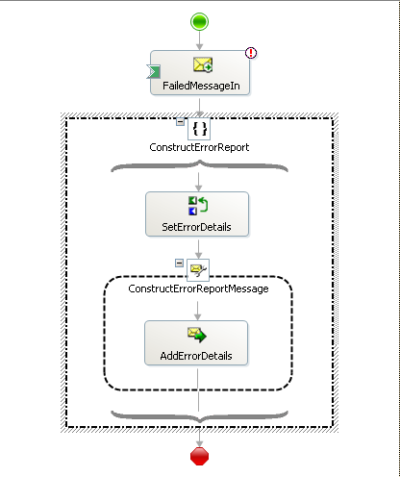
- Add a send shape to the orchestration. | - Right-click the down arrow below the Construct ErrorReport scope shape, point to Insert Shape, and then click Send.  - In the Properties window for the send shape, change the Name to ErrorReport OUT, and then set the Message to ErrorReportMessage.
- Configure the orchestration receive port.  You are able to directly bind this orchestration to the message box database because of the Filter Expression that was set on the receive shape in step 3. | - Right-click the left Port Surface of the Orchestration Designer, and then click New Configured Port.  - In the Port Configuration Wizard, click Next.  - On the Port Properties page, change the Name to GetFailedMessages, and then click Next.  - On the Select a Port Type page, set the Port Type Name to GetFailedMessages_Type, and then click Next.  - On the Port Binding page, select I’ll always be receiving messages on this port for the Port direction of communication, choose Direct from the Port binding list, then verify that Routing between ports will be defined by filter expressions on incoming messages in the Message Box database, and then click Next.  - Click Finish.
- Configure the orchestration send port. | - Right-click the right Port Surface of the Orchestration Designer, and then click New Configured Port.  - In the Port Configuration Wizard, click Next.  - On the Port Properties page, change the Name to ErrorReportSend, and then click Next.  - On the Select a Port Type page, set the Port Type Name to ErrorReportSend_Type, and then click Next.  - On the Port Binding page, choose I’ll always be sending messages on this port for the Port direction of communication, and then click Next.  - Click Finish.
- Connect the orchestration ports to the send and receive shapes. | - Click the green connector on the GetFailedMessages receive port and drag it to the Failed Message IN receive shape.  - Click the green connector on the ErrorReportSend receive port and drag it to the ErrorReport OUT send shape.  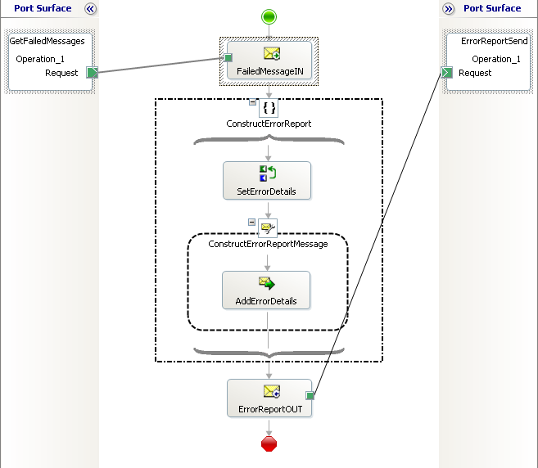

Exercise 7
Deploy, Configure, and Test the Application
Now that the error handling orchestration has been built, you can test the entire process.
In this exercise you will deploy the project with the newly created ErrorHandler orchestration. You will create a new send port for the ErrorHandler orchestration, and then you will configure the bindings and start the application. Once the application is running, you will submit an invalid message via email, fix the message using the SharePoint site, and then resubmit the message and complete the business process.

Tasks | Detailed steps
- Deploy the BizTalk project. | - In Solution Explorer, right-click the ErrorHandling project, and then click Deploy.
- Restart the BizTalk Host Instance | - In BizTalk Server 2010 Administration Console, expand Platform Settings, and then click Host Instances.  - Right-click BizTalkServerApplication, and then click Restart.
- Create a new send port.  This port will be used to send the failed messages to a SharePoint form library where they will be evaluated and/or fixed by a business worker.  The custom send pipeline adds the appropriate processing instruction to the outgoing message so it will open with the correct InfoPath form, displaying the error information. | - In the BizTalk Administration Console, right-click the Lab7 application, and then click Refresh  - In the BizTalk Administration Console, expand the Lab7 application, right-click Send Ports, point to New, and then click Static One-way Send Port.  - In the Send Port Properties window, change the Name to SndErrorWSS, choose Windows SharePoint Services from the Type list, and then click Configure.  - In the Windows SharePoint Services Transport Properties dialog box, configure the properties as shown in the table below.  - Click OK.  - On the Send Port Properties page, change the Send pipeline to SendError.  - Click OK.
  Property | Value
  Adapter Web Service Port | 80
  Destination Folder URL | Failed Expense Reports
  SharePoint Site URL | http://localhost
- Configure the application. | - In the BizTalk Administration Console, right-click the Lab7 application, and then click Refresh.  - In the BizTalk Administration Console, right-click the Lab7 application, and then click Configure.  - In the left pane of the Configure Application window, click ErrorHandler.  - Set the Host to BizTalkServerApplication; from the Send Ports/Send Port Groups list below, select SndErrorWSS, and then click OK.  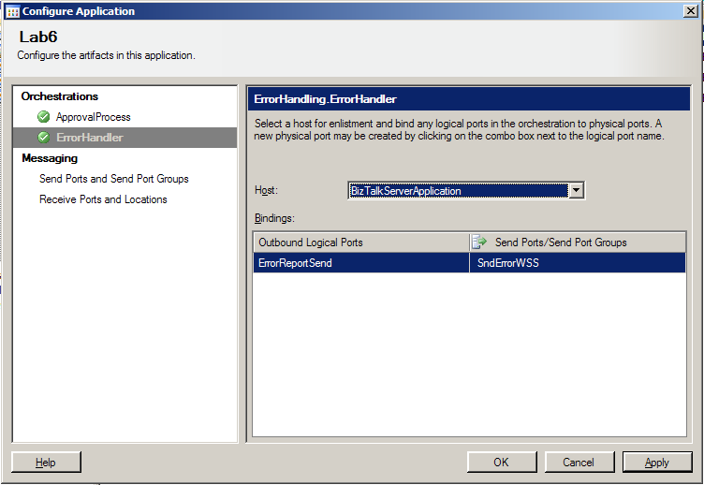
- Start the application. | - Right-click the Lab7 application, and then click Start.  - In the Start ‘Lab7’ Application dialog box, click Start.
- Submit an invalid expense report.  The invalid expense report does not meet the criteria set by the schema. The Email Address is missing the “.com” from the end. | - Open Windows Live Mail, if it isn’t already open.  - Click the Create Mail button.  - In the New Message window, type Expenses@bts2010.com in the To line, then type Submit Expenses in the Subject line.  - In the Insert menu, click File Attachment.  - In the Insert Attachment dialog box, navigate to C:\Labs\Work\Lab 7\Messages, click WithError.xml, and then click Attach.  - Click Send.
- Fix the invalid message.  The error details have been added to the original message to provide troubleshooting information to the business worker. | - In Internet Explorer, navigate to http://localhost .  - In the left section, click Documents and then click the Failed Expense Reports link.  - Click the Msg-GUID link.  - In the File Download dialog box, click Open.  - In the top section of the form read the Description, notice the last line which reads: The document failed to validate because of the following error:"The 'http://ExpenseReports.ExpenseReport:Email' element has an invalid value according to its data type.".  - In the Expense Report section, change the Report Date to today’s date, and then add the .com to the end of the email address which is causing the error from the Address.  - In the File menu, click Save As (You may have to click the down arrows at the bottom of the file menu to expose the Save As command).  - In the Save As dialog box, navigate to C:\Labs\Work\Lab 7\Messages, change the File name to Fixed.xml and then click Save.  - Close InfoPath.
- Submit the fixed message.  The fixed message will now be processed in the same way as the other valid messages. | - In Windows Live Mail, click the Create Mail button.  - In the New Message window, type Expenses@bts2010.com in the To line, then type Submit Expenses in the Subject line.  - In the Insert menu, click File Attachment.  - In the Insert Attachment dialog box, navigate to C:\Labs\Work\Lab 7\Messages, clickFixed.xml, and then click Attach.  - Click Send.  - In Internet Explorer, in the Sharepoint site, under Libraries select Expense Reports.  - Click the newest Msg-GUID link.  - In the File Download dialog box, click Open.  - Change the Status to Approved, then in the File menu, click Save, and then close InfoPath.  - Under Libraries, click Processed Expense Reports. (You may have to refresh this page)  - Click the most recent Msg-GUID link to view the approved message.
- Delete the application | - In BizTalk Server 2010 Administration Console, right-click on the Lab7 application and select Stop.  - If the Options tab isn’t visible – click on the options button to expand the Stop Options tab.  - Select the Full Stop – Terminate Instances radio button  - Click Stop.  - After the stop-progress is complete, right-click on the Lab7 application again and select Delete.  - Expand Platform Settings > Host Instances in the tree view, and select BizTalkServerApplication in the right-hand pane. Right-click and select Restart.

